Prof. Dr. Adel M. Awadallah,
Dean of scientific research at the Islamic University
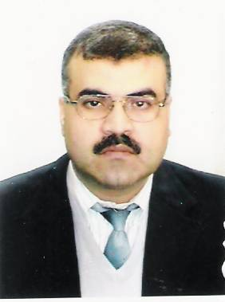
Chemistry Department, Faculty of Science,
Islamic University of Gaza
P. O. Box108
Tel. +970-8-2823311 Fax: +970-8-2823310,
Email: awada@iugaza.edu.ps
Gaza, Palestine
ACADEMIC HISTORY:
1- Ph.D. of Organic Chemistry at the University of Essen, Germany, 1995.
2- Master of Science in Chemistry, University of Jordan, Amman, Jordan 1989.
3- Bachelor of science in Chemistry at Bir-Zeit University Palestine (1986).
4- Diploma of Education, Jordan University, Amman, Jordan 1991.
5- High school (scientific stream) Gaza, 1981.
6- Bachelor degree in Islamic Shariah, 2006 (from the Islamic University of Gaza)

Academic Status and Experience:
1- Assistant Professor at the Islamic University of Gaza, Palestine since 1995
2- Associate Professor at the Islamic University of Gaza, Palestine since 2001
3- Full Professor of organic Chemistry, 2006
4- Head of chemistry Department at the Islamic University of Gaza, Palestine (1997-1999)
5- Dean of scientific research at the Islamic University of Gaza, Palestine (2003- )
6- Participating in many committees in and out of the University.
7- Head of the committee of (The Islamic University Prize for Scientific research)
8- Editor of the (Islamic University Journal – Series of Natural Studies and Engineering)

